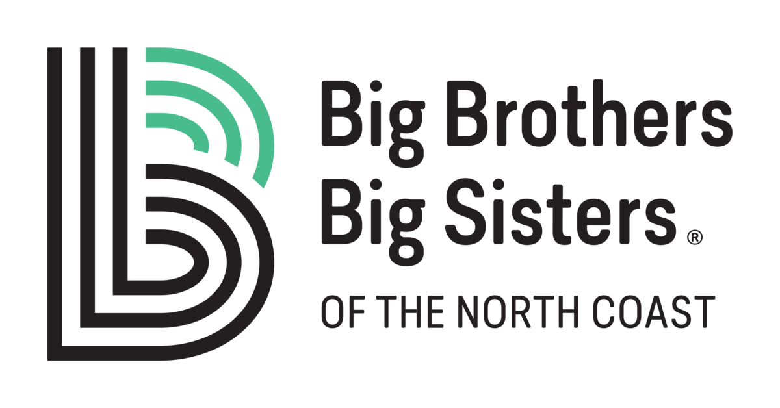

BIG BROTHERS BIG SISTERS OF THE NORTH COAST

Position Title: Executive Director

Position Summary:

The Executive Director is the Chief Administrative Officer of Big Brothers Big Sisters of the North Coast, reporting to the Board of Directors and its Executive Committee, and is accountable and responsible for all operations of the agency. In exercising the following responsibilities, the Executive Director operates within the guidelines of the By-Laws of the agency, the policies of the Board and the Standards of BBBS of America.

Responsibilities:

- Serves as Executive Officer of the Board of Directors enabling it to meet its constitutional and legal responsibilities and to maintain the standards of BBBS of America.

Key Activities:
- Acts as an advisor to the Board of Directors, keeping Board informed of agency operations and community needs, so that it has adequate information for carrying out its policy-making and planning functions. This includes ex-officio (without vote) membership on all committees.
- With the President of the Board ensures that the Board is organized to effectively implement the range of its responsibilities.
- Assists and advises the Board of Directors and its committees in the establishment of long- and short-range agency goals and objectives.
- Oversees the implementation of the goals and policies of the Board.

- As the agent of the Board, is responsible for employment, evaluation, training, and termination of staff, administration of the personnel policies and organization of the staff to carry out the programs and services of BBBSNC.

Key Activities:
- Works with the Personnel Ad Hoc Committee to ensure that legal requirements of employers are met and to develop and review personnel policies. Implements policies and personnel goals.
- Ensures the regular review of job descriptions and annual review of salary ranges.
- Plans and/or assigns responsibility for orientation, supervision, appraisal, development and growth of staff.
- Schedules regular meetings of staff to keep them informed and enable them to participate appropriately in development and implementation of plans and goals of the agency.
- Maintains personnel records according to policies and legal requirements.

- Oversees the fiscal management of the agency and initiates and expedites financial planning processes to assure the future of BBBSNC.

Key Activities:
- Ensures that the Budget and Finance Committee and Treasurer understand their responsibilities and have access to the information needed for them to carry out their responsibilities.
- Provides leadership in budget planning to ensure input from all committees and focuses on accomplishing the plans of the agency.
- Ensures that the Board of Directors has clear and accurate reports of the agency’s financial position and is aware of its legal and contractual obligations
- Assists the Board of Directors in developing adequate funding for the agency.

Key Activities:
- Researches the availability of and actively pursues the securing of programmatic and general purpose grants from foundations and other sources.
- Ensures that a financial development plan is formulated and carried out by the Board and volunteers.
- Supports event chairs and committees and delegates staff support to maximize the success of all fund-raising efforts.
- Grows agency funding base through strategic pursuit of grant and fundraising activities.

- Ensures an effective, consistent image of the agency, its mission and its volunteer and funding needs.

Key Activities:
- Advises the Board of Directors in developing a public relations and recruitment plan.
- Ensures that staff and volunteers are trained to assist in the implementation of the plan.
- Personally acts as a representative and interpreter of the agency’s services and needs.

- Ensures the delivery of all program services according to Minimum Practice Standards as developed by BBBS of America.

Key Activities:
- Supervises and monitors program development and implementation with the Program Manager.
- Works closely with the Program Committee as it does an evaluation of the agency’s service delivery.
- Stays abreast of program and service issues and developments.
- Pursue program growth opportunities to expand mentoring opportunities.

Core Competencies and Experience:
- Fund development, Donor stewardship and retention,
- Grant Writing and Management,
- Excellent verbal/written communications
- Strategic and Visionary leader
  - Strategic thinking, planning, and project/process/systems management skills
  - Ability to lead complex, multi-component projects to successful outcomes
- Project and Campaign management,
  - Ability to negotiate and influence effectively in high impact situations with stakeholders
- Exceptional organizational skills,
  - Ability to prioritize tasks and manage time efficiently
- Understanding of technical Programs Including:
  - Google Suite, Microsoft: Outlook, Word, Excel, Teams
  - Salesforce and QuickBooks,
- Experience with non-profit management and/or social welfare agencies,
- Bachelor’s Degree required.

