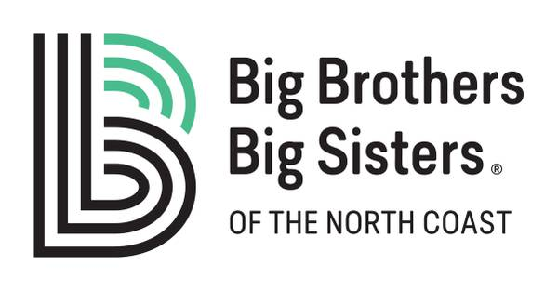
- We envision a world where all youth achieve their full potential.
Our mission: to build and support one-to-one relationships to ignite the biggest possible futures for youth.
Enrollment and Match Support Specialist
Reports to: Executive Director and Program Manager
Works in coordination with: Agency staff and volunteers
Hours per week: 32
Compensation: Starting at $21.50/hour
To apply: Email cover letter, résumé, and at least 3 non-personal references to office@ncbbbs.org. Résumés without cover letters will not be considered. No phone calls, please. Position open until filled.
Job Summary: Under the direction of the Program Manager, the Enrollment and Match Support Specialist is responsible for developing, fostering, and supporting the high quality, professional relationship with the family, youth, and volunteers. This position is the primary point of contact for parties involved in the match, and the ideal candidate must be able to use independent judgment while incorporating BBBS standards to ensure program compliance and success. Additionally, this position includes child and volunteer recruitment. Applicant must be willing to travel to community-based sites on occasion. Flexible work hours to meet customer needs are required.
Enrollment

- Ensure high-level proficiency in applying child safety and risk management knowledge, policies, and procedures throughout all aspects of job function.
- Identify child safety issues for volunteers, children, and their families.
- Increase volunteer and child enrollment through recruitment and outreach.
- Conduct school-based and community-based volunteer and client enrollments, including:
Parent, youth, and volunteer interviews
Individual/or group orientations; both in-person and virtual
Volunteer training
Child safety education
- Completion of enrollment processes including background checks, references, and surveys
- Provide timely and comprehensive reports and recommendations for participation in the program based upon assessments of each individual participant.

Match Support

- Provide ongoing support throughout the match to all participants including but not limited to the following areas:
Child safety
Match relationship development
Positive youth development through creating and measuring goals
Problem solving
Volunteer satisfaction
Ideas for activities
- Ensure appropriate follow-up and check-in calls are made in accordance with BBBS standards, at a minimum. Additional contact may be required based on individual circumstances.
- Maintain high-quality internal and external relationships
- Look for opportunities to continually expand supportive services provided to participants.
Program

- Provides information to internal partners to assist with revenue growth and stewardship of supporters
- Uses interpersonal skills and makes sound judgment to achieve maximum effectiveness
- Facilitates cross-channel feedback within the organization
- Observes, reviews, and analyzes processes to identify inefficiencies and areas where improvements could be made
- Serves as a back-up to various staff as needed
- Ensure compliance with all BBBS policies, standards, and safety and security regulations
- Performs other duties as assigned and/or required
Overall Responsibilities:

- Attend staff meetings
- Submit accurate and timely reports—time sheets, monthly work reports, etc.
- Participate in agency-wide activities
- Represent Big Brothers Big Sisters of the North Coast to the public
- Maintain positive working relationships with internal and external partners
- Assist with agency events and fundraisers as needed
- All other duties as assigned
Qualifications:

- Bachelor's degree in social services or related field
- Ability to speak and understand English fluently (Spanish fluency a plus)
- Assessment and relationship development experience with children and adults
- Understanding of child development and family dynamics
- Computer skills—Microsoft Office, Teams, Word, Outlook and Excel and ability to learn agency databases
- Ability to travel to community-based sites. Must have valid drivers’ license, reliable vehicle, and state required insurance
- Must successfully pass a background check
- Must be able to complete mandated reporter training within 30 days of hire

Physical Demands and Work Environment:
- Excellent oral and written communication skills reflecting solid customer service in-person, by telephone and email
- Ability to form and sustain appropriate relationships based on positive youth development and volunteer satisfaction
- Evening and weekend availability
- Effectively assess and execute the following relational support skills: guiding, supporting, confronting, advising and/or negotiating
Relate well in multicultural environments
Effectively collaborate with other staff, use time effectively, and focus on details
Ability to collect and analyze meaningful data
Equal Employment Opportunity
BBBSA provides equal employment opportunities to all qualified individuals without regard to race, creed, color, religion, national origin, age, sex, marital status, sexual orientation, or non-disqualifying physical or mental handicap or disability.
Americans with Disabilities Act
Applicants as well as employees who are or become disabled must be able to perform the essential duties & responsibilities either unaided or with reasonable accommodation. The organization shall determine reasonable accommodation on a case-by-case basis in accordance with applicable law.
Job Responsibilities
The above statements reflect the general duties, responsibilities and competencies considered necessary to perform the essential duties & responsibilities of the job and should not be considered as a detailed description of all the work requirements of the position. BBBSA may change the specific job duties with or without prior notice based on the needs of the organization.

