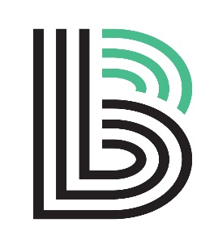
Big Brothers Big Sisters of the North Coast

PRIZE DONATION FORM

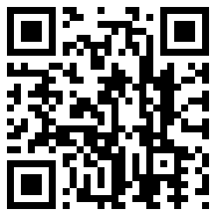
Please mail/fax/deliver completed form or provide donation item to:
Big Brothers Big Sisters of the North Coast
PO Box 5510, Eureka CA 95502 Office: 428 C Street, #G, Eureka
E-Mail: office@ncbbbs.org Phone: 445-4871, Fax: 445-1405

Donation item: __________________________________________________________________________

Value: $______________________ Cash donation: $ ___________________________

Business: _______________________________________________________________

Contact person: _________________________________________________________

Address: _______________________________________________________________

City, State, Zip: __________________________________________________________

Phone: ___________________________ Fax: ________________________________

Email: _________________________________________________________________

I need a receipt:  YES  NO I would like item picked up:  YES  NO

NOTES: ________________________________________________________________

BBBSNC STAFF USE: RECEIVED: Date:____________ Initials: __________
RECEIPT & TY: Date:____________ Initials: __________
DATA ENTERED: Date: ____________ Initials: __________

THANK YOU FOR SUPPORTING MENTORING SERVICES FOR

HUMBOLDT COUNTY YOUTH!



